**Comparative Study of Countries**

An Insurance company is expanding and wants to open new branches in various parts of the world. Our task is to compare various parameters such as income, life insurance share, market share, penetration, ratio of reinsurance accepted, and retention ratio of different countries using the sample insurance dataset and world development indicators dataset. Which are:

(i)Primary Dataset – Insurance Sample Dataset

(ii)Secondary Dataset – Global Financial Development Database

**Objective:** Being the data analyst of the company, publish a dashboard to compare all the parameters mentioned above for different countries, to strategize market penetration and to target new customers. Kindly use the following project URL for reference.

‘<https://public.tableau.com/app/profile/sai.santosh.k.s/viz/Project1_16804625711940/ComparisionofCountries> ‘

Questions:

1. Create a geographic map showing the countries' fields. Color the map based on the income column from the secondary dataset, Include income group filter in the dashboard.

Ans:

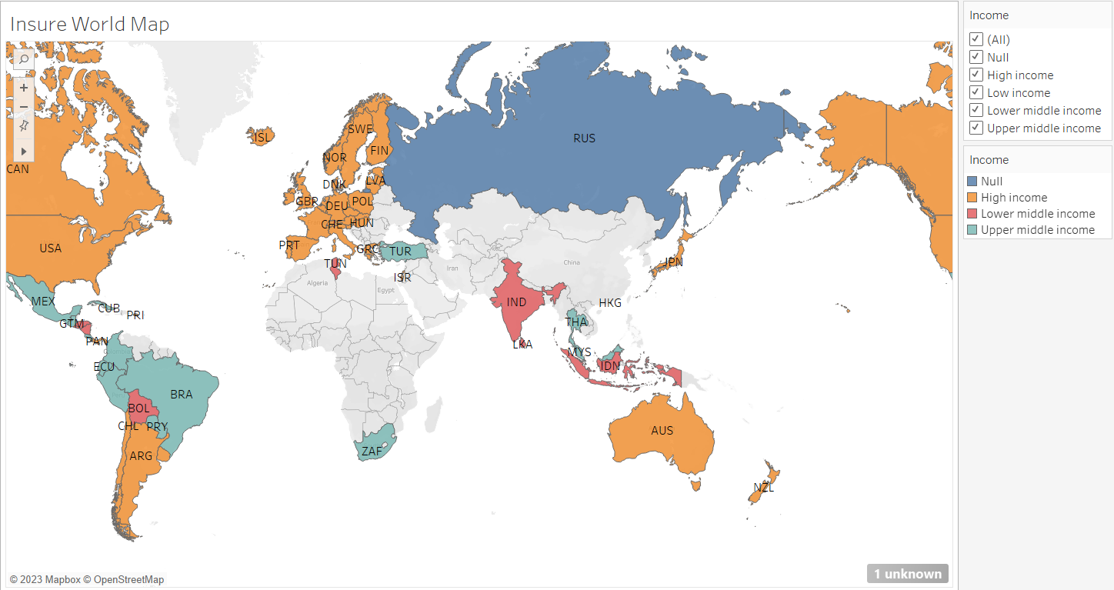

The above map gives us the idea of which countries have higher income and stable income to penetrate their insurance market. The map also show that western part of the world has more high-income earning countries than the rest of the world.

1. Create a KPI Table to show the comparison between the selected period and the period prior to the selected one

* Create two parameters for Year Selection and Category Selection
* Category parameter includes life insurance share, market share, penetration, ratio of reinsurance accepted, and retention ratio
* Create a calculated field to calculate the Growth %
* Create a table to show these values
* Title should be updated based on the category selection

Ans: By creating the calculated fields and assigning the parameter for the data to predict the growth of different parameter by comparing their current and previous year growth and growth percentage.  
  
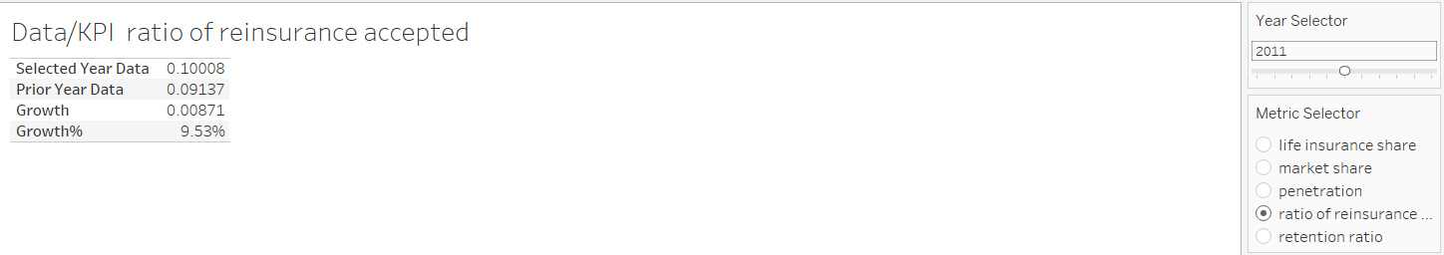

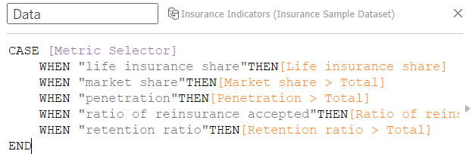

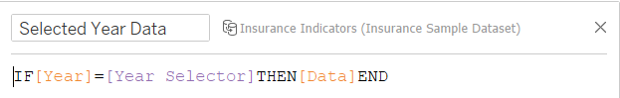

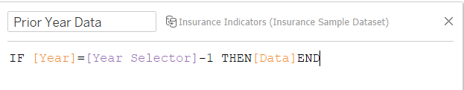

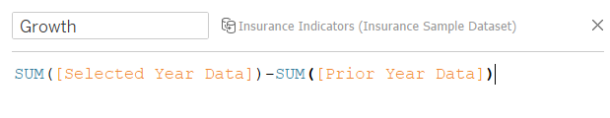

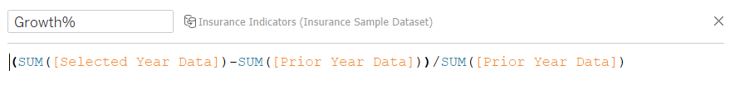

1. Create Growth Indicator Shapes based on the Growth %. Growth indicator displays Negative, No Change, and Positive as values and corresponding shapes against it.

Ans: By creating a calculating field for the growth indication based on the KPI data build for the previous question. The indicator shows us the impact of various parameters and what kind of impact it’s having in the different income earning countries.

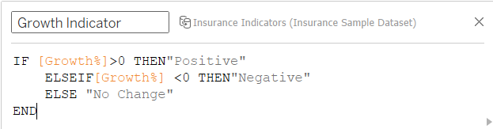

The kinds of impact are:

Positive:

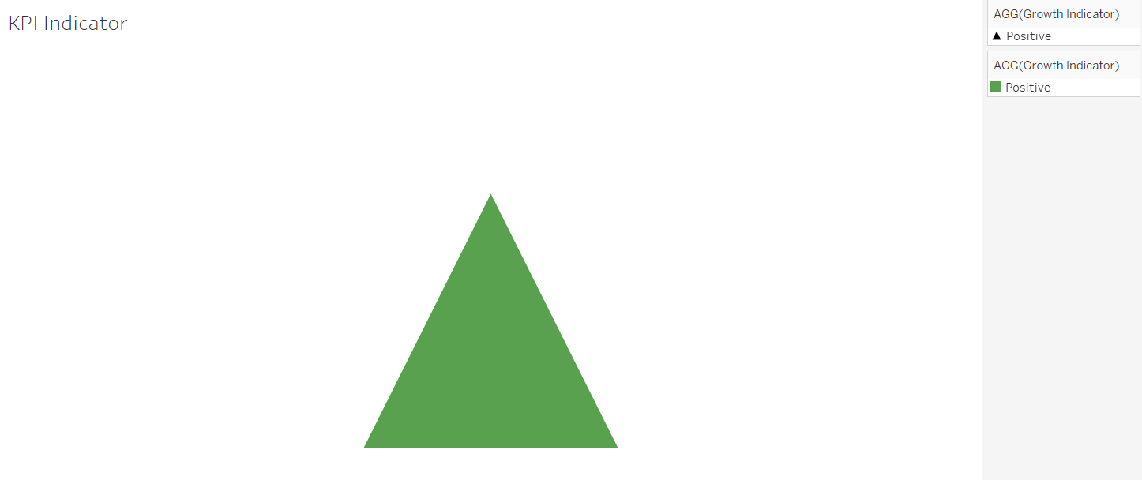

Negative:

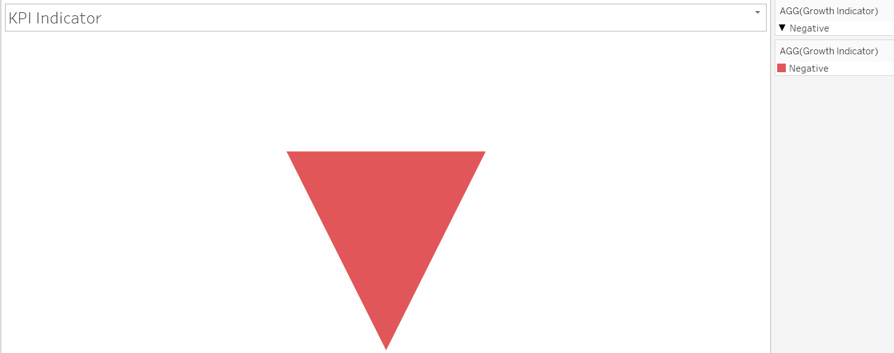

No Change:

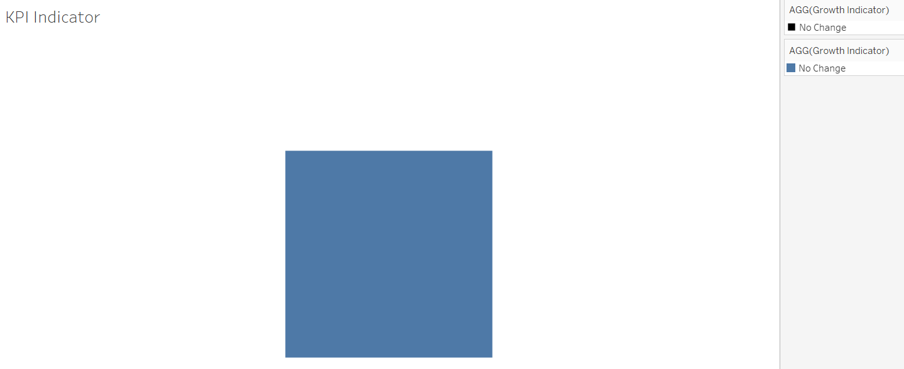

1. Create a trend line to show the selected category values. The line shows an arrow or triangle at the last mark.

Ans: The trend line shows the growth movement of the different parameters for different year indicating their performance in the income earning countries. Implying us to tell if we can have the targeted audience in the respective country or not.

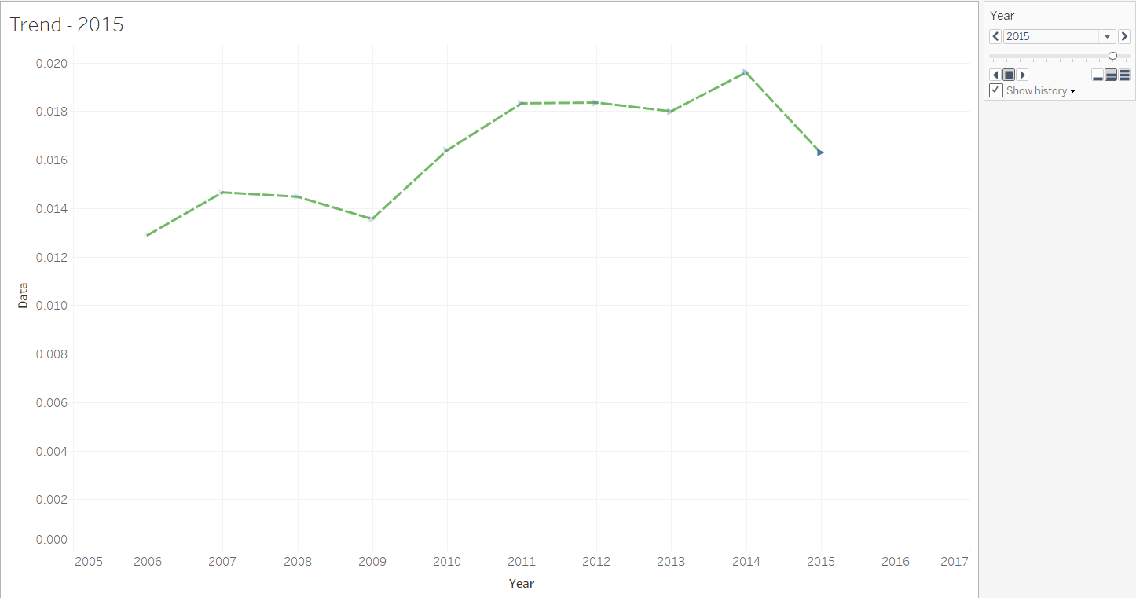

1. Create a dashboard filter for income group to be applied for all charts with the filter action enabled in the map as well. Include a webpage to show data from the world bank webpage driven by an URL action from a geography graph

(i)The country names in the map will act as the trigger.

Ans: The Dashboard contains all the different charts created for the comparison in a single tab to provide a better overview of the different countries with high, upper middle or lower middle income earning countries, With the filter action enabled in map and also linked to all the charts, by clicking on the desired country on the map one can get a glance of all the charts showing the details of that particular country for all the parameters and also the webpage of that country from wiki source.

